1.4 Main Equipment — Exercises
Table of Contents

1.4 Main Equipment in Air Conditioning Systems

1.4.1 Overview — The Four Component Groups
Every vapor compression air conditioning system contains the same four functional components introduced in Topic 1.3. In practical systems, each of these functions is fulfilled by a specific piece of equipment available in a range of types, capacities, and configurations. This topic examines the principal equipment options for each function.
Figure 1.13 shows the four equipment groups arranged in the refrigeration loop, with the most common equipment types listed under each group.
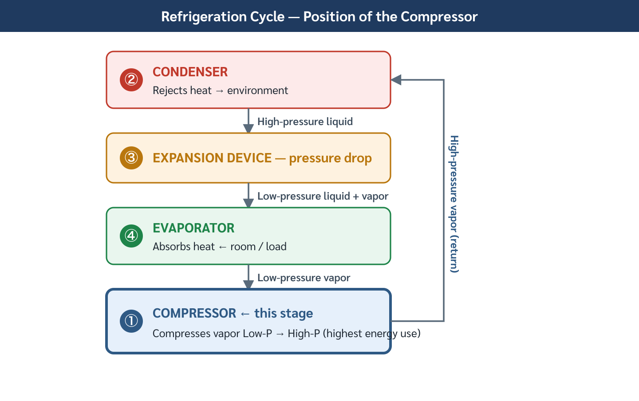
Figure 1.13 — Main Equipment Groups in the Vapor Compression AC System
Figure 1.13 — Main Equipment Groups in the Vapor Compression AC System
Source: Praphan, Air Conditioning Engineering, p. 3

1.4.2 Compressors
The compressor is the heart of the refrigeration system — it consumes the most electrical energy and determines system capacity. Compressors are classified by their operating principle.

A. Reciprocating Compressor
Operating principle: Pistons moving inside cylinders draw in low-pressure refrigerant vapor on the suction stroke and compress it on the discharge stroke — identical in concept to a petrol engine, but running refrigerant instead of air-fuel mixture.
Characteristics: - Capacity range: 0.5 – 30 TR (1.8 – 105 kW) - Efficiency: moderate (COP 2.5–3.5 for small units) - Common in: window units, small split-type systems, small commercial equipment - Advantages: simple, inexpensive, widely available, easy to service - Disadvantages: vibration, noise, valve wear, limited capacity control (on/off or cylinder unloading)
Figure 1.14 shows the reciprocating compressor operating principle — suction and discharge strokes.
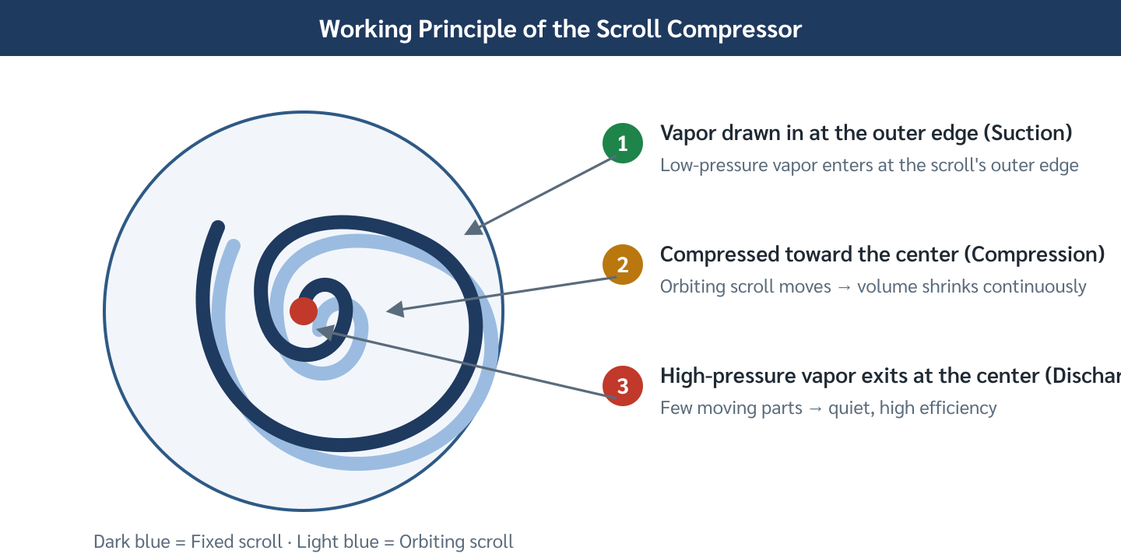
Figure 1.14 — Reciprocating Compressor Operating Principle
Figure 1.14 — Reciprocating Compressor Operating Principle
Source: ASHRAE Refrigeration Handbook

B. Scroll Compressor
Operating principle: Two spiral-shaped scrolls — one fixed, one orbiting — trap pockets of refrigerant vapor between them. As the orbiting scroll moves, the pockets decrease in volume, compressing the gas toward the center where it exits at high pressure.
Characteristics: - Capacity range: 1 – 60 TR (3.5 – 210 kW) - Efficiency: good (COP 3.0–4.5 for residential/light commercial) - Common in: residential split-type systems, small to medium package units, VRF outdoor units - Advantages: smooth (few moving parts), quiet, compact, no suction/discharge valves to wear out - Disadvantages: not field-serviceable (hermetically sealed), efficiency drops at high compression ratios

C. Screw Compressor
Operating principle: Two interlocking helical rotors (male and female) rotate together. Refrigerant vapor is trapped in the grooves between the rotors at the suction end and carried along the rotor length to the discharge end, where the decreasing groove volume compresses the gas.
Characteristics: - Capacity range: 20 – 1,000 TR (70 – 3,500 kW) - Efficiency: good at full load, excellent at part load with slide valve capacity control - Common in: medium to large chillers, industrial refrigeration - Advantages: continuous compression (no pulsation), reliable, good part-load efficiency - Disadvantages: requires precise machining tolerances, oil injection for sealing/cooling

D. Centrifugal Compressor
Operating principle: An impeller rotating at high speed (up to 20,000 RPM) adds kinetic energy to the refrigerant vapor. The vapor then passes through a diffuser where velocity is converted to pressure. This is a dynamic compressor — unlike the positive-displacement types above, it uses velocity to raise pressure.
Characteristics: - Capacity range: 100 – 5,000+ TR (350 kW – 17,500+ kW) - Efficiency: excellent at full load (COP 5.0–7.5 for large centrifugal chillers) - Common in: large central chilled water plants, district cooling, large commercial buildings - Advantages: very high efficiency at design point, smooth operation, compact per unit capacity - Disadvantages: surge at low-load conditions, requires variable inlet guide vanes (VIGV) for part-load control, high capital cost
Figure 1.15 compares the four compressor types by capacity range and typical application.
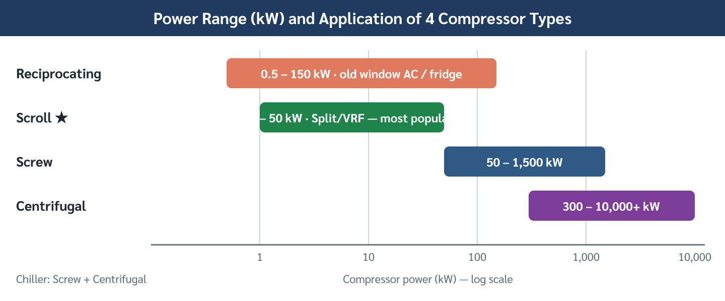
Figure 1.15 — Compressor Types: Capacity Range and Application
Figure 1.15 — Compressor Types: Capacity Range and Application
Source: ASHRAE Equipment Handbook

1.4.3 Condensers
The condenser rejects heat from the refrigerant to a heat sink. The choice of condenser type determines how and where this heat is rejected, and significantly affects system efficiency.

A. Air-Cooled Condenser
Operating principle: Refrigerant vapor flows through finned coil tubes. Outdoor air is drawn or forced across the fins by propeller fans. Heat transfers from refrigerant to air; air is discharged to the atmosphere.
Characteristics: - Heat sink: outdoor air - Condensing temperature: typically 15–25°F (8–14°C) above outdoor dry-bulb temperature - Common in: split-type systems, package units, rooftop units, small to medium commercial - Advantages: simple, no water system required, low maintenance - Disadvantages: efficiency decreases significantly on hot days; occupies roof/outdoor space; noise from fans
Design rule of thumb: For air-cooled condensers in Thailand, design condensing temperature = outdoor dry-bulb + 20°F (11°C). If outdoor design = 95°F (35°C), condensing temperature = 115°F (46°C).

B. Water-Cooled Condenser
Operating principle: Refrigerant vapor flows through tubes; cooling water flows over or around the tubes (shell-and-tube heat exchanger). The heated water is then pumped to a cooling tower where evaporative cooling rejects heat to the atmosphere.
Characteristics: - Heat sink: cooling water (rejected via cooling tower) - Condensing temperature: typically 10–15°F (6–8°C) above cooling water supply temperature - Cooling water supply: typically 85°F (29°C) from cooling tower - Condensing temperature: typically 95–100°F (35–38°C) - Common in: chillers in large buildings, industrial processes - Advantages: lower condensing temperature → higher COP (typically 20–40% more efficient than air-cooled for same capacity); suitable for high-capacity systems - Disadvantages: requires cooling tower, water treatment, condenser water pumps; higher capital and maintenance cost
Figure 1.16 shows the temperature difference advantage of water-cooled over air-cooled condensers.
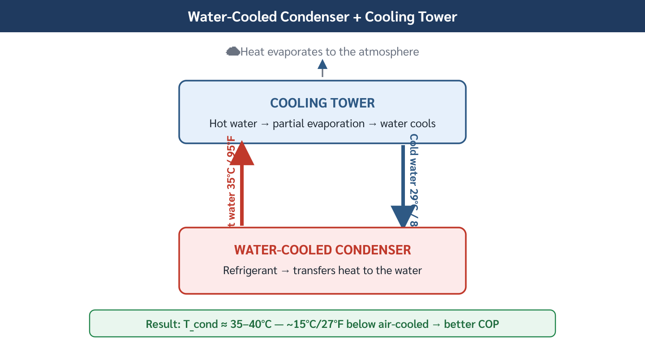
Figure 1.16 — Condensing Temperature Comparison: Air-Cooled vs Water-Cooled
Figure 1.16 — Condensing Temperature Comparison: Air-Cooled vs Water-Cooled
Source: ASHRAE Systems & Equipment Handbook

C. Evaporative Condenser
Operating principle: Refrigerant coils are sprayed with water while air is drawn through. Heat is rejected primarily through evaporation of the water spray — not through sensible heat to the air. This allows condensing temperatures approaching the outdoor wet-bulb temperature.
- More efficient than air-cooled (approaches wet-bulb, not dry-bulb)
- Eliminates the separate cooling tower and condenser water pumps required by shell-and-tube water-cooled systems
- Common in: industrial refrigeration, large ammonia systems

1.4.4 Expansion Devices
The expansion device controls the flow of liquid refrigerant into the evaporator, maintaining the correct pressure differential between high side and low side.

A. Thermostatic Expansion Valve (TXV)
Operating principle: A valve controlled by a sensing bulb attached to the evaporator outlet. The bulb pressure responds to the superheat of the refrigerant leaving the evaporator. If superheat is too high (evaporator starved), the valve opens more; if too low, it closes.
- Maintains constant superheat at evaporator outlet (typically 10–20°F / 6–11°C)
- Automatically adjusts to varying load conditions
- Common in: most commercial split-type systems, package units, larger residential systems
- Requires: correct bulb placement, correct refrigerant charge

B. Electronic Expansion Valve (EEV)
Operating principle: A stepper-motor or pulse-width-modulated valve controlled by an electronic controller that reads multiple sensors (suction pressure, discharge pressure, temperatures). The controller calculates optimal valve position using a control algorithm.
- More precise control than TXV → better efficiency, especially at part-load
- Essential for inverter-driven (variable-speed) systems and VRF systems
- Responds faster than TXV, can control to superheat of 3–5°F (2–3°C)
- Higher cost, requires electronic controller

C. Capillary Tube
Operating principle: A fixed-diameter tube of precise length and bore that restricts refrigerant flow through viscous and turbulent pressure drop. No moving parts — flow rate is determined by the pressure difference across the tube.
- No moving parts → extremely reliable, low cost
- Fixed flow rate — cannot adapt to varying load
- Requires precise refrigerant charge (±5% affects performance significantly)
- Common in: domestic refrigerators, window air conditioners, small hermetic systems
- Not suitable for systems with variable load or large capacity
Figure 1.17 compares the three expansion device types by control capability and application.
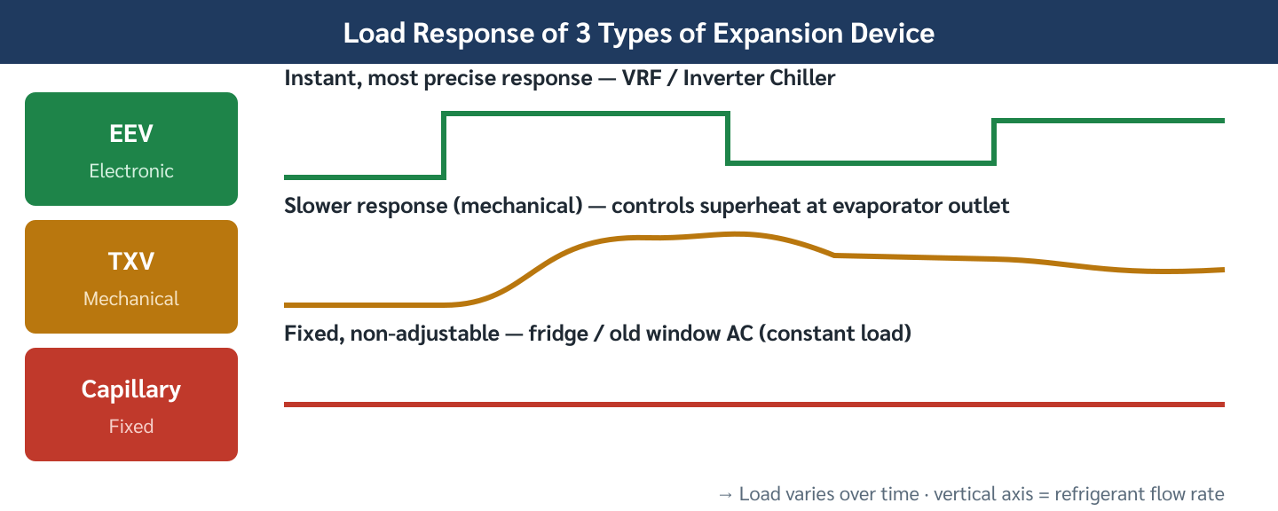
Figure 1.17 — Expansion Device Comparison
Figure 1.17 — Expansion Device Comparison
Source: ASHRAE Refrigeration Handbook

1.4.5 Evaporator-Side Air Distribution Equipment
In comfort air conditioning, the evaporator coil is housed inside an air distribution unit that moves conditioned air through the building. Two principal configurations exist:

A. Air Handling Unit (AHU)
An AHU is a central unit — typically large (capacity 5–500 TR equivalent airflow) — that conditions and distributes air to multiple zones through a ductwork system.
Typical AHU components (in airflow order): 1. Return air inlet + mixing with fresh air 2. Filter section (pre-filter + fine filter) 3. Cooling coil (chilled water or direct expansion) 4. Heating coil (optional — hot water or electric) 5. Supply fan (forward-curved, backward-curved, or plug fan) 6. Discharge to supply duct
Applications: Office floors, hotel common areas, hospitals, airports — any large open space requiring central air distribution.

B. Fan Coil Unit (FCU)
An FCU is a small, self-contained unit that includes a coil and a fan in one compact housing, installed within each individual room or zone.
FCU configurations: - Ceiling-concealed (duct-connected or ceiling-mounted, most common in Thai hotels) - Floor-standing console (hotel rooms, perimeter installations) - Cassette type (4-way discharge, flush-mounted in ceiling grid) - Wall-mounted (small offices, retail)
FCU vs. AHU comparison:
Parameter | AHU (Central) | FCU (Distributed)
Location | Central plant room | Each room/zone
Capacity | Large (5–500 TR equiv.) | Small (0.2–5 TR equiv.)
Duct system | Extensive ductwork required | Minimal (chilled water piping only)
Zone control | By VAV box or zoned dampers | Individual thermostat per FCU
Fresh air | Built into AHU | Requires separate DOAS system
Maintenance | Centralized | Distributed — one unit per room
Figure 1.19 shows the AHU and FCU configurations in a typical hotel building, illustrating the difference in air distribution strategy.
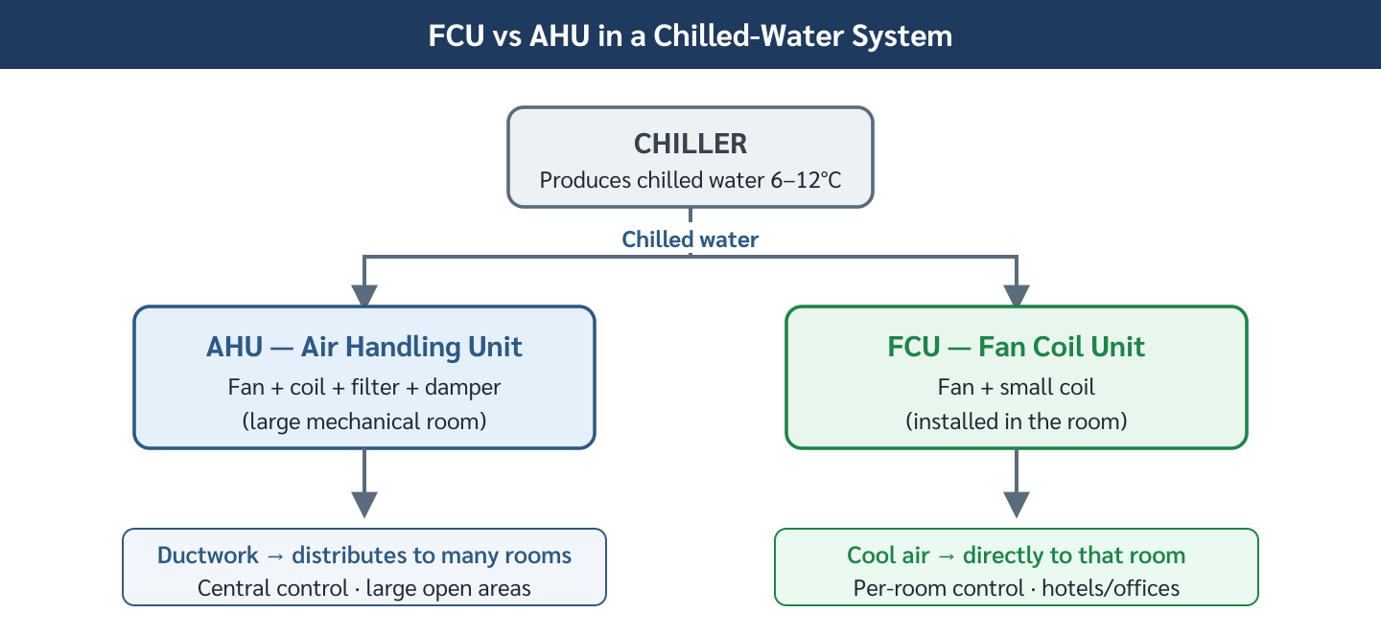
Figure 1.19 — AHU vs FCU Air Distribution Strategies
Figure 1.19 — AHU vs FCU Air Distribution Strategies
Source: ASHRAE Systems & Equipment Handbook

Summary — Topic 1.4
- Compressors — four types: Reciprocating (small, simple), Scroll (quiet, residential/VRF), Screw (medium-large chiller), Centrifugal (large plant, highest efficiency)
- Condensers — Air-cooled (simple, hotter condensing, lower COP) vs. Water-cooled + cooling tower (lower condensing, higher COP, ~20–40% more efficient) vs. Evaporative (approaches wet-bulb)
- Expansion devices — Capillary tube (fixed, domestic), TXV (variable load, commercial), EEV (precision, VRF/inverter)
- Air distribution — AHU (central, ductwork, large zones) vs. FCU (distributed, individual room control, chilled water piping)
- Equipment selection is driven by capacity, efficiency target, capital budget, and building type

Reference: ASHRAE Equipment Handbook; ASHRAE Fundamentals Handbook; Praphan, Air Conditioning Engineering, pp. 3–6 Status: draft — English version, written fresh from source

Topic 1.4 — Worked Examples: Main AC Equipment

Example 1 — Compressor Selection for a Hotel Building
Problem: A 200-room hotel in Chiang Mai requires a central air conditioning plant. The preliminary design specifies two identical chillers, each handling 50% of the total cooling load. The total building peak cooling load is estimated at 600 TR (2,110 kW). Determine the appropriate compressor type for each chiller, and justify the selection.
Given: - Total peak cooling load: 600 TR (2,110 kW) - Each chiller: 300 TR (1,055 kW) - Building type: hotel (24-hour operation, variable occupancy) - Location: Chiang Mai — outdoor design: 95°F DB / 78°F WB (35°C / 26°C)
Solution:
Step 1 — Determine capacity per chiller.
$$Q_{chiller}=\frac{600\text{ TR}}{2}=300\text{ TR} (1,055\text{ kW})$$
Step 2 — Narrow down compressor type by capacity.
From the capacity ranges in Section 1.4.2:
Type | Range (TR) | Covers 300 TR?
Reciprocating | 0.5–30 | No
Scroll | 1–60 | No
Screw | 20–1,000 | ✓ Yes
Centrifugal | 100–5,000+ | ✓ Yes
Both Screw and Centrifugal cover 300 TR.
Step 3 — Compare Screw vs. Centrifugal for this application.
Factor | Screw | Centrifugal
COP at full load | 4.0–5.5 | 5.5–7.0
Part-load efficiency | Excellent (slide valve) | Good (VIGV), risk of surge <30%
Capital cost | Lower | Higher
Hotel load profile | 20–100% (variable) | Surge risk at low occupancy
Hotel buildings typically operate at part-load 60–70% of the time. Both types are technically feasible at 300 TR.
Recommendation: Screw compressor chillers — provide reliable part-load operation across the full 20–100% load range without surge risk, at competitive capital cost for a mid-size hotel.
If the building were a large office tower with a predictable 8 AM–6 PM schedule, centrifugal chillers would be preferred for their superior full-load efficiency.
Answer:
$$\text{Selected compressor type: }\text{Screw} \text{(2 × 300 TR screw chillers)}$$

Example 2 — Air-Cooled vs. Water-Cooled Condenser: COP Comparison
Problem: A convenience store chain is selecting a 10 TR (35.2 kW) packaged air conditioning unit for a new store in Bangkok. Two options are available:
- Option A: Air-cooled split system — condensing temperature = 115°F (46°C)
- Option B: Water-cooled packaged unit — condensing temperature = 100°F (38°C)
Both options use R-410A. The evaporating temperature is 45°F (7.2°C) for both.
a) Calculate the ideal (Carnot) COP for each option. b) If the actual COP is 60% of Carnot COP, calculate the annual electricity cost difference. Assume the store operates 18 hours/day, 365 days/year, electricity cost = ฿5.00/kWh.
Given: - Cooling capacity: 10 TR = 35.2 kW - Evaporating temperature: $T_{L}$ = 45°F = 7.2°C = 280.4 K - Condensing temperature (A): $T_{H}$ = 115°F = 46.1°C = 319.3 K - Condensing temperature (B): $T_{H}$ = 100°F = 37.8°C = 310.9 K - Actual COP = 0.60 × COP$​_{Carnot}$ - Operating hours: 18 h/day × 365 days = 6,570 h/year
Solution:
Part a — Carnot COP:
$$COP_{Carnot}=\frac{T_{L}}{T_{H}−T_{L}}$$
Option A (Air-Cooled):
$$COP_{A}=\frac{280.4}{319.3−280.4}=\frac{280.4}{38.9}=7.21$$
Option B (Water-Cooled):
$$COP_{B}=\frac{280.4}{310.9−280.4}=\frac{280.4}{30.5}=9.19$$
Water-cooled COP is 27% higher than air-cooled — purely from the lower condensing temperature.
Part b — Annual electricity cost:
Actual COP:
$$COP_{A,actual}=0.60×7.21=4.33$$
$$COP_{B,actual}=0.60×9.19=5.51$$
Power input:
$$W_{A}=\frac{Q}{COP_{A}}=\frac{35.2}{4.33}=8.13\text{ kW}$$
$$W_{B}=\frac{Q}{COP_{B}}=\frac{35.2}{5.51}=6.39\text{ kW}$$
Annual energy consumption:
$$E_{A}=8.13×6,570=53,414\text{ kWh/year}$$
$$E_{B}=6.39×6,570=41,982\text{ kWh/year}$$
Annual electricity cost:
$${\text{Cost}}_{A}=53,414×5.00=\text{฿}267,070/\text{year}$$
$${\text{Cost}}_{B}=41,982×5.00=\text{฿}209,910/\text{year}$$
$$Δ\text{Cost}=267,070−209,910=\text{฿57,160/year}$$
Interpretation: The water-cooled system saves ฿57,160/year in electricity. However, Option B requires a cooling tower, water treatment system, and condenser water pump — adding ฿80,000–150,000 to capital cost. The simple payback period is approximately:
$$\text{Payback}=\frac{Δ\text{Capital}}{Δ\text{Annual Savings}}≈\frac{100,000}{57,160}≈1.75\text{ years}$$
For a long-running convenience store, the water-cooled option is economically justified despite higher first cost.

Example 3 — Expansion Device Selection and TXV Superheat
Problem: A 5 TR (17.6 kW) split-type commercial air conditioner uses R-22. The TXV is set to maintain 15°F (8.3°C) superheat at the evaporator outlet.
a) Explain the physical meaning of 15°F superheat and why it is important. b) If the suction pressure corresponds to a saturation temperature of 45°F (7.2°C), what is the actual suction temperature at the compressor inlet? c) If the superheat drops to 5°F (2.8°C), what risk does this pose?
Solution:
Part a — Meaning of superheat:
Superheat is the temperature rise of refrigerant vapor above its saturation temperature at the same pressure.
$$\text{Superheat}=T_{actual,vapor}−T_{sat}|_{P=P_{suction}}$$
A superheat of 15°F means the vapor leaving the evaporator is 15°F hotter than the boiling point at that pressure. This ensures: 1. All refrigerant has fully vaporized — no liquid droplets remain in the suction line 2. Liquid slugging is prevented — liquid refrigerant entering the compressor causes catastrophic valve damage 3. TXV has a stable control signal — the sensing bulb reads a repeatable temperature difference
Part b — Suction temperature:
$$T_{suction}=T_{sat}+ΔT_{superheat}=45+15=60°F (15.6°C)$$
The compressor receives vapor at 60°F (15.6°C), 15°F above the evaporating temperature of 45°F (7.2°C).
Part c — Risk at 5°F superheat:
If superheat falls to 5°F, the refrigerant leaving the evaporator is very close to the saturation point. Small variations in load can cause the refrigerant to reach the compressor as a wet mixture (liquid + vapor).
Consequences: - Liquid refrigerant cannot be compressed → hydraulic lock → connecting rod or valve failure - Oil dilution — liquid refrigerant dissolves compressor oil, reducing lubrication - Compressor failure within hours to days of sustained operation
Correct response: Adjust TXV setting to increase superheat back to 15°F, or verify refrigerant charge level is correct.
$$\text{Rule: }T_{suction}<T_{sat}+8°F\text{ → DANGER zone for any reciprocating/scroll compressor}$$

Reference: ASHRAE Refrigeration Handbook; Praphan, Air Conditioning Engineering, pp. 3–6 Status: draft — English, written from source

Topic 1.4 — Exercises: Main AC Equipment
Difficulty: ★ Easy · ★★ Intermediate · ★★★ Challenging

Exercise 1 ★ — Compressor Classification
A building engineer is reviewing equipment specifications for four air conditioning systems installed in a campus:
System | Description
A | 1.5 TR window unit in a small office, hermetically sealed motor, pistons visible in service manual
B | 20 TR rooftop packaged unit, twin helical rotors, slide-valve capacity control
C | 0.75 TR split-type residential unit, two interlocking spiral elements, inverter motor
D | 400 TR centrifugal chiller, impeller at 15,000 RPM, inlet guide vane control
a) Identify the compressor type for each system (A, B, C, D). b) Which two compressors are positive-displacement type? Which is dynamic? c) Which compressor type is most suitable if the building later adds a 600 TR chiller plant for district cooling? Justify briefly.
Answer
a) - A: Reciprocating (pistons, hermetic, small capacity) - B: Screw (helical rotors, slide-valve, 20 TR) - C: Scroll (interlocking spirals, inverter-compatible, residential) - D: Centrifugal (impeller, VIGV, large capacity)
b) Positive-displacement: A (reciprocating), B (screw), C (scroll) Dynamic: D (centrifugal only)
c) Centrifugal — capacity range 100–5,000+ TR, highest full-load COP, smooth operation; district cooling operates at near-constant design load → ideal for centrifugal compressors (no surge risk at full load).

Exercise 2 ★ — Condenser Type Selection
A hospital project team is comparing two condenser options for a 150 TR chiller:
- Option A: Air-cooled condenser — condensing temperature = 120°F (49°C)
- Option B: Water-cooled condenser + cooling tower — condensing temperature = 100°F (38°C)
Evaporating temperature for both: 42°F (5.6°C) = 278.8 K.
a) Convert condensing temperatures to Kelvin. b) Calculate the Carnot COP for each option. c) State TWO non-energy reasons why a hospital might prefer the water-cooled option.
Answer
a)
$$T_{H}^{A}=120°F=48.9°C=322.0\text{ K}$$
$$T_{H}^{B}=100°F=37.8°C=310.9\text{ K}$$
$$T_{L}=42°F=5.6°C=278.8\text{ K}$$
b)
$$COP_{A}^{Carnot}=\frac{278.8}{322.0−278.8}=\frac{278.8}{43.2}=6.46$$
$$COP_{B}^{Carnot}=\frac{278.8}{310.9−278.8}=\frac{278.8}{32.1}=8.69$$
c) Any two of: 1. Hospitals require 24/7 reliability — water-cooled chillers are more reliable in extreme heat (air-cooled loses capacity on hot days) 2. Noise — air-cooled condensers with propeller fans create outdoor noise; hospitals require quiet environments 3. Roof space — a large air-cooled condenser requires significant roof area; hospitals have competing roof equipment (HVAC intakes, helipad, etc.) 4. Higher capacity systems are better served by water-cooled (air-cooled rarely exceeds 200 TR per unit)

Exercise 3 ★ — Expansion Device Properties
Match each expansion device to its correct characteristic. Each characteristic applies to exactly one device.
Devices: (i) Capillary tube, (ii) TXV, (iii) EEV
Characteristics: - [P] No moving parts; fixed-bore tube; flow determined by pressure difference - [Q] Stepper-motor-driven; controller reads suction pressure and temperature sensors simultaneously - [R] Mechanical valve; sensing bulb on evaporator outlet; maintains constant superheat - [S] Requires precise refrigerant charge (±5%); cannot adapt to varying load - [T] Required for inverter-driven (variable-speed) systems; fastest response time
Answer
Characteristic | Device
P | (i) Capillary tube
Q | (iii) EEV
R | (ii) TXV
S | (i) Capillary tube
T | (iii) EEV

Exercise 4 ★★ — TXV Superheat Calculation
An air conditioning system uses R-410A. At the current operating condition: - Suction pressure: 109.9 psia (757.7 kPa) - Saturation temperature at suction pressure: 40°F (4.4°C) - Actual suction temperature measured at compressor inlet: 58°F (14.4°C)
a) Calculate the actual superheat in °F and °C. b) The TXV is set for 15°F superheat. Is the current superheat within an acceptable range (±5°F of setpoint)? State the risk if superheat is too low. c) If load increases and the evaporator starves, the superheat rises to 28°F (15.6°C). Explain what the TXV does in response, and what happens to refrigerant mass flow rate.
Answer
a)
$$ΔT_{superheat}=T_{actual}−T_{sat}=58−40=18°F (14.4−4.4=10°C)$$
b) Acceptable range: 15°F ± 5°F = 10°F to 20°F. 18°F is within range — ✓ acceptable.
Risk if superheat too low (< 8°F): wet vapor or liquid droplets enter the compressor → liquid slugging → valve failure, oil dilution → compressor failure.
c) When superheat rises to 28°F: - The sensing bulb temperature increases → bulb pressure increases - Higher bulb pressure overcomes spring force → TXV opens wider - More refrigerant mass flow into evaporator → evaporator fills more completely → superheat returns toward setpoint - Mass flow rate: increases (valve opens → more liquid metered in)
This is the TXV’s self-regulating feedback action — it continuously hunts around the superheat setpoint.

Exercise 5 ★★ — AHU vs. FCU System Selection
A 20-story mixed-use tower is being designed in Chiang Mai: - Floors 1–3: Retail (large open floor plates, 1,500 m² per floor) - Floors 4–18: Office (open-plan, 1,200 m² per floor, 8 AM–6 PM schedule) - Floors 19–20: Hotel suites (80 rooms total, 24-hour operation, individual guest control essential)
a) Recommend the appropriate air distribution system (AHU or FCU) for each zone (retail, office, hotel suites). Justify each choice. b) The hotel management specifies that each guest must be able to independently control room temperature from 20–26°C. Which system achieves this, and what is the minimum additional equipment needed? c) The office tenant requests fresh air at 0.15 CFM/ft² (0.76 L/s·m²). Can an FCU system meet this requirement independently? Explain.
Answer
a) - Retail (Floors 1–3): AHU — large open floor plates require high-volume central air distribution; occupancy is variable but zoning is not room-by-room; a few large AHUs serving the retail floor with VAV boxes is cost-effective - Office (Floors 4–18): AHU with VAV — open-plan offices benefit from central high-efficiency AHU; schedule-based operation matches AHU design; fresh air can be integrated; VAV boxes provide zone control - Hotel (Floors 19–20): FCU — individual guest control per room is the primary requirement; FCUs allow independent thermostatic control per room; chilled water distribution to 80 FCUs is straightforward
b) FCU system achieves individual room control. Minimum additional equipment: - Individual room thermostat (2-pipe or 4-pipe control valve per FCU) - Chilled water (and heating) supply piping to each room - For 4-pipe FCU: separate chilled water and hot water circuits for simultaneous cooling/heating in different rooms
c) No — FCUs cannot independently meet fresh air requirements. The FCU recirculates room air across the coil; no outdoor air intake is provided. To meet fresh air requirements: - A separate Dedicated Outdoor Air System (DOAS) or fresh air handling unit (FAHU) is required - Fresh air is pre-conditioned (cooled and dehumidified) and ducted to each room or to the FCU mixing plenum

Exercise 6 ★★★ — Equipment Optimization: Variable-Speed Screw Chiller
A large office complex has a water-cooled screw chiller rated at 300 TR (1,055 kW) at design conditions: - Condensing temperature: 105°F (40.6°C) = 313.7 K - Evaporating temperature: 42°F (5.6°C) = 278.8 K - Rated full-load COP (actual): 5.0 - Full-load compressor power: 210 kW
The building operates at 40% of peak load (120 TR = 422 kW of cooling) for 60% of annual operating hours and at 100% load for the remaining 40% of hours. Total annual operating hours = 4,000 h/year.
a) At full load, verify that the given COP is consistent: $COP=Q_{cooling}/W_{comp}$. b) Assume the chiller COP at 40% load = 6.2 (higher due to slide-valve unloading reducing compressor work more than proportionally). Calculate the compressor power at 40% load. c) Calculate the total annual energy consumption (kWh) for both the full-load and part-load periods. d) The chiller is upgraded with a variable-speed drive (VSD) on the compressor. At 40% load, COP improves to 7.5. Calculate the annual energy savings compared to part (c), and the CO₂ emission reduction (assume Thailand grid: 0.564 kg CO₂/kWh).
Answer
a) Verification:
$$COP=\frac{Q_{cooling}}{W_{comp}}=\frac{1,055\text{ kW}}{210\text{ kW}}=5.02≈5.0✓$$
b) At 40% load:
$$Q_{40\%}=0.40×1,055=422\text{ kW}$$
$$W_{40\%}=\frac{Q_{40\%}}{COP_{40\%}}=\frac{422}{6.2}=68.1\text{ kW}$$
c) Annual hours: - Full-load: $0.40×4,000=1,600$ h/year - Part-load: $0.60×4,000=2,400$ h/year
Annual energy:
$$E_{full}=210×1,600=336,000\text{ kWh}$$
$$E_{part}=68.1×2,400=163,440\text{ kWh}$$
$$E_{total}=336,000+163,440=499,440\text{ kWh/year}$$
d) With VSD at 40% load, $COP_{VSD}=7.5$:
$$W_{VSD,40\%}=\frac{422}{7.5}=56.3\text{ kW}$$
$$E_{VSD,part}=56.3×2,400=135,120\text{ kWh}$$
$$E_{VSD,total}=336,000+135,120=471,120\text{ kWh/year}$$
Energy savings:
$$ΔE=499,440−471,120=28,320\text{ kWh/year}$$
CO₂ reduction:
$$ΔCO_{2}=28,320×0.564=15,972{\text{ kg CO}}_{2}\text{/year}≈16{\text{ tonnes CO}}_{2}\text{/year}$$
Variable-speed drives on large chillers typically offer 5–20% annual energy savings — largest benefit at part-load, which dominates most commercial building operating profiles.

Reference: ASHRAE Refrigeration Handbook; ASHRAE Systems & Equipment Handbook; Praphan, Air Conditioning Engineering, pp. 3–6 Status: draft — English, written from source

